# Power BI – Assessment

Duration: 2.5 hrs.

Total Marks: 100

**Dataset:**

**Assignment:**

This assignment is aimed at evaluating the candidates on their PowerBI – Modeling, PowerBI – Querying (DAX) and PowerBI - Reporting skillsets.

Use the provided dataset to create a Fact Dimensional model in Power BI to produce a Sales Dashboard that helps the users to analyze the sales data across varying dimensional parameters

And your data model would look something like below:

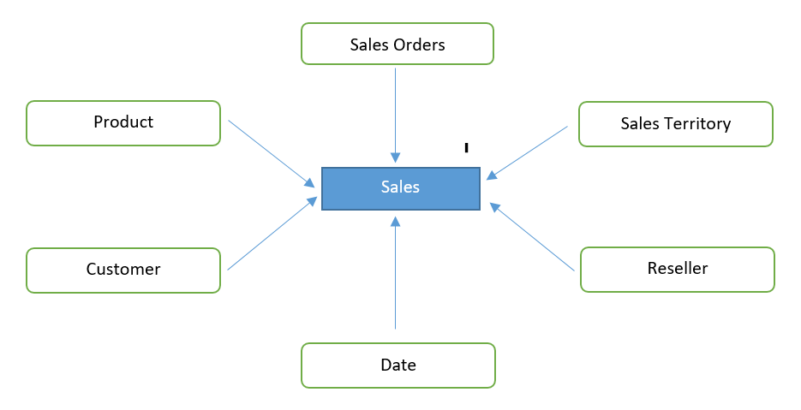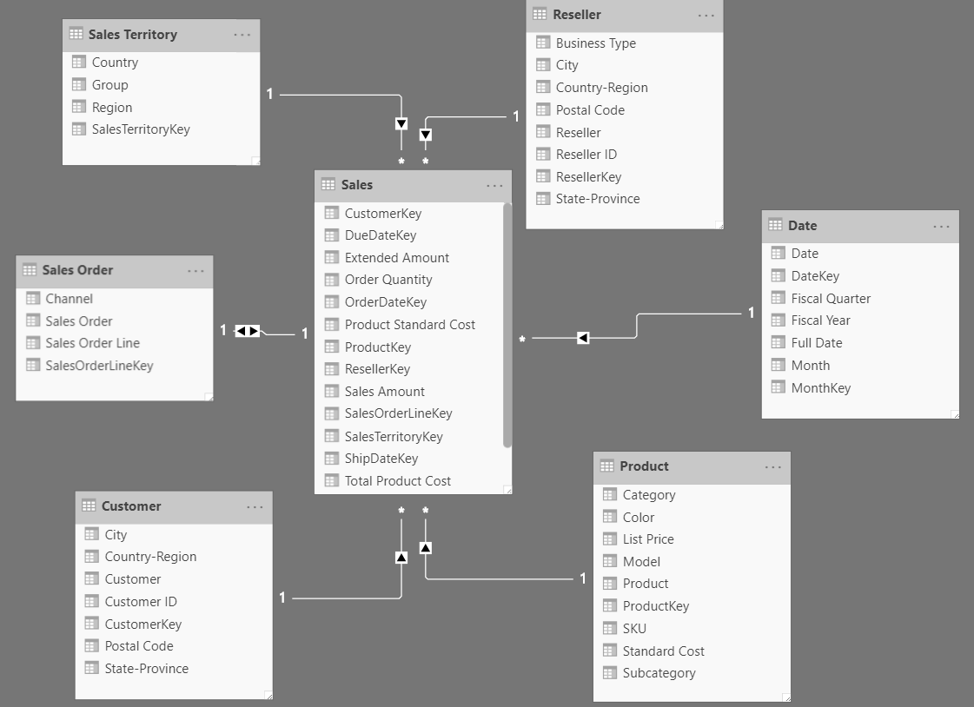

**Key Columns Mapping**

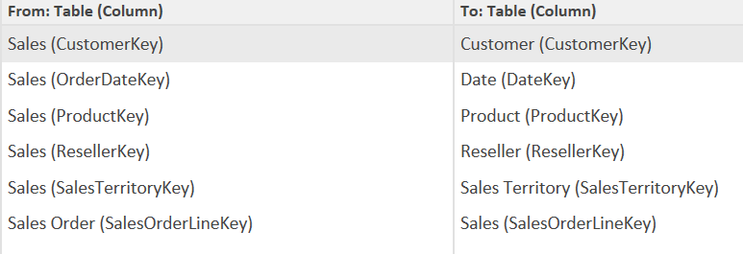

Develop a dashboard by creating reports/visuals on the following scenarios with the dataset and model provided.

1. Create a new column to derive Sales Profit which should be a Sales Amount – Total Product Cost. (5 marks) **Output** - Please share the screenshot of the Dax query.
2. Create a new column Delivery status with two outcomes (Ontime , Delayed) based on the difference between ShipDate and DueDate. Display the number of orders fulfilled Ontime and Delayed using card visuals. (15 marks)

**Output –**

1. Provide the screenshot of all the derived column’s Dax queries
2. Provide the screenshot of the PBI Visual created based on the derived columns
3. Create a time hierarchy in Date Dimension. Year(TopMost) --> Quarter-->Month -> Date (bottom most). (5 marks)

**Output –** Provide the screenshot of the Time hierarchy that you created

1. Create a pie chart to display Total Sales Amount across Territory and use Month on Slicer. (15 marks)

**Output –** Provide the screenshot of the Visuals you created

1. Create a visual to show the top 10 Resellers with high Sales Profit (10 marks)

**Output –** Provide the screenshot of the Visuals you created

1. Choose an appropriate visual to portray Sales Growth across time. Use Time hierarchy in drill down. (15 marks)

**Output –** Provide the screenshot of the Visuals you created

1. Create a measure to derive the Total Sales amount of Europe region with Dax and display it in an appropriate Visual (15 marks)

**Output –**

1. Provide the screenshot of the Measure you created using DAX
2. Provide the screenshot of the Visual you created
3. Create a Matrix to display the Total Number of Orders placed, Total Sales Amount & Sales Profit via different Channels (Internet/Reseller) across different periods of time and Implement Drill through functionality to drill across Year-Quarter-Month. (20 marks)

**Output –** Provide the screenshot of the Visuals you created